*A*

*Report*

*Submitted in partial fulfilment of the Requirements for the award of the Degree of*

***BACHELOR OF TECHNOLOGY***

***IN***

### INFORMATION TECHNOLOGY

By

**P.ROSHINI<1602-20-737-032>**

**Under the Guidance of**

**B. Leelavathy**



**Department of Information Technology Vasavi College of Engineering (Autonomous) (Affiliated to Osmania University) Ibrahimbagh, Hyderabad-31**

**2021-2022**

BONAFIDE CERTIFICATE

This to Certify that the project report titled

## “AUTOMATIC FUEL TRACKER IN VEHICLES” project work of MISS.P.ROSHINI bearing Roll.no:1602-20-737-032 who carried out this project under my supervision in the IV semester for the academic year 2021-2022.

*Signature Signature*

*external examiner internal examiner*

# ABSTRACT:

This is project “Automatic fuel tracker in vehicles“. Product quality has entered the consciousness of organizations with a vengeance. It has become crystal clear that high-quality products have a distinct advantage in the market place, that market share can be gained or lost over the quality issue.

Therefore, quality is a competitive priority. Quality is the only factor that ensures an organization's survival and growth. Quality focuses on meeting consumer need, meeting the competition, improving continuously and extending these concerns to all phases of business. Today, it has been well understood by managers that the real price of poor quality is lost consumers and ultimately, the death of an organization. Therefore, to be successful in today's business environment, organizations must pay attention to quality. Hence, a systematic procedure has to be evolved and followed and different concepts of quality management have to be understood clearly for designing and executing the quality management programme effectively and every information regarding the product should be crystal clear and this project gives us the quality and information about the product.so the product can be redesigned again for further improvement and development.

**THROUGH THE PROJECT:**

This project helps to store data in a efficient way and it can be achieved through various sql commands and we can also store this for any future use and also we can save our data in a many different areas so we cannot lost all the data at once. The quality and product details are must in now a days because quality matters every where, these project stores details and feedback and testing details in database so that whenever it is necessary to know how and when a product can be used.

**ARCHITECTURE AND TECHNOLOGY USED:**

**SOFTWARE USED:**

Java Eclipse, Oracle 11g Database, Java SE version 8, SQL Plus.

**Java SWING:**

**Swing** is a GUI widget toolkit for Java. It is part of Oracle's Java Foundation Classes (JFC) – an API for providing a graphical user interface (GUI) for Java programs.

Swing was developed to provide a more sophisticated set of GUI components than the

earlier AWT. Swing provides a look and feel that emulates the look and feel of several platforms, and also supports a pluggable look and feel that allows applications to have a look and feel unrelated to the underlying platform. It has more powerful and flexible components than AWT. In addition to familiar components such as buttons, check boxes and labels, Swing provides several advanced components such as tabbed panel, scroll panes, trees, tables, and lists.

**SQL:**

Structure Query Language (SQL) is a database query language used for storing and managing data in Relational DBMS. SQL was the first commercial language introduced for E.F Codd's **Relational** model of database. Today almost all RDBMS (MySql, Oracle, Infomix, Sybase, MS Access) use **SQL** as the standard database query language. SQL is used to perform all types of data operations in RDBMS.

**Java-SQL Connectivity using JDBC:**

**Java Database Connectivity** (**JDBC**) is an application programming

interface (API) for the programming language Java, which defines how a client may access a database. It is a Java-based data access technology used for Java database connectivity. It is part of the Java Standard Edition platform,

from Oracle Corporation. It provides methods to query and update data in a database and is oriented towards relational databases.

The connection to the database can be performed using Java programming (JDBC API) as:

try

{

}

Class.*forName*("oracle.jdbc.driver.OracleDriver");

catch (Exception e)

{

System.*err*.println("Unable to find and load driver"); System.*exit*(1);

}

public void connectToDB()

{

try

{

connection = DriverManager.*getConnection*("jdbc:oracle:thin:@localhost:1522:ORCL","mydbms","mydbms");

statement = connection.createStatement();

}

catch (SQLException connectException)

{

System.*out*.println(connectException.getMessage()); System.*out*.println(connectException.getSQLState()); System.*out*.println(connectException.getErrorCode()); System.*exit*(1);

}

}

Thus, the connection from Java to Oracle database is performed and therefore, can be used for updating tables in the database directly

ABSTRACT: HERE IN AUTOMATIC FUEL TRACKER IN VEHICLES WHEN BARCODE IS SCANNED IT WILL SHOW THE DETAILS OF VEHICLE SUCH AS VEHICLE ID (WHICH IS NAME PLATE OF VEHICLE), VEHICLE CONSUMES WHICH TYPE OF FUEL, OWNER NAME, CONTACT DETAILS (MOBILE NUMMBER) IT WILL ALSO DISPLAY THE CAPACITY OF FUEL WHICH VEHICLE CAN HOLD, FUEL CONSUMED BY VEHICLE, FUEL LEFT IN THE VEHICLE.

REQUIREMENTS GATHERING: HERE IT WILL HAVE THE VEHICLES, CONSUMPTION TABLE, BARCODE TABLE, INDICATOR TABLE, TRACKER TABLE.

ER DIAGRAM: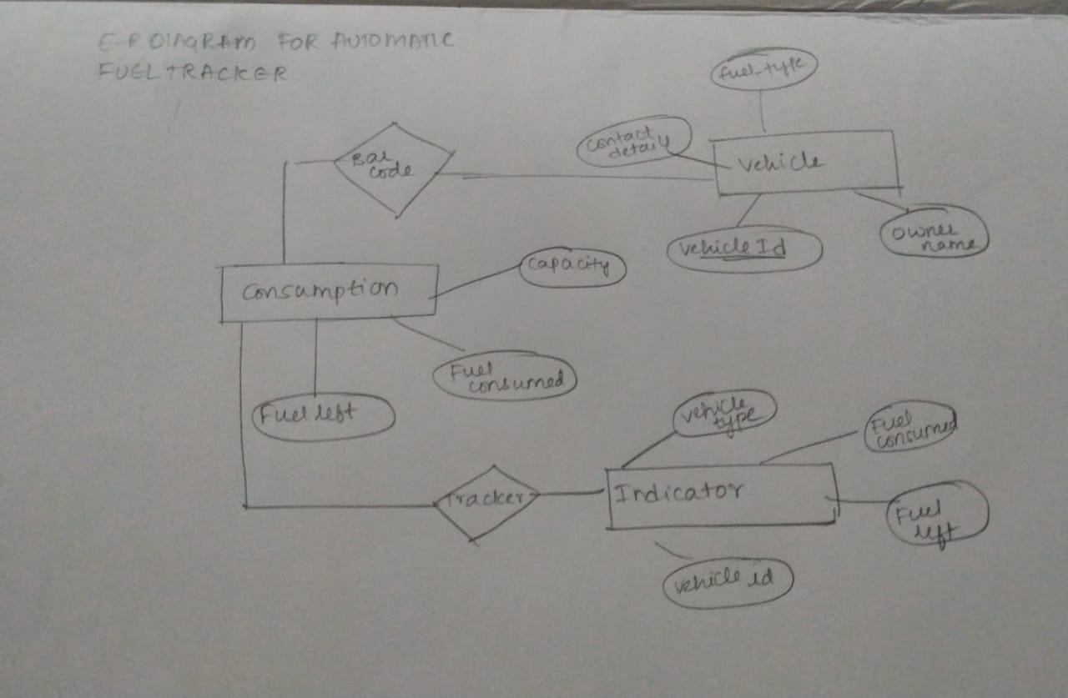

RELATIONAL MODEL:

1.CREATE TABLE VEHICLE(VEHICLE_ID VARCHAR2(50),OWNER_NAME VARCHAR2(50),CONTACT NUMBER(30),FUEL_TYPE VARCHAR2(50);

2.CREATE TABLE CONSUMPTION(CAPACITY NUMBER(30),FUEL_CONSUMED NUMBER(30),FUEL_LEFT NUMBER(30));

3.CREATE TABLE BARCODE (VEHICLE_ID VARCHAR2(50), FUEL_TYPE(30));

4. CREATE TABLE TRACKER(VEHICLE_ID VARCHAR2(50),VEHICLE_TYPE(50),FUEL_CONSUMED NUMBER(30),FUEL_LEFT NUMBER(30));

5 CREATE TABLE INDICATION(FUEL_LEFT NUMBER(50),VEHICLE_IDVARCHAR2(50),DISTANCE_WILL_COVER NUMBER(30),FUEL-TYPE NUMBER(30));

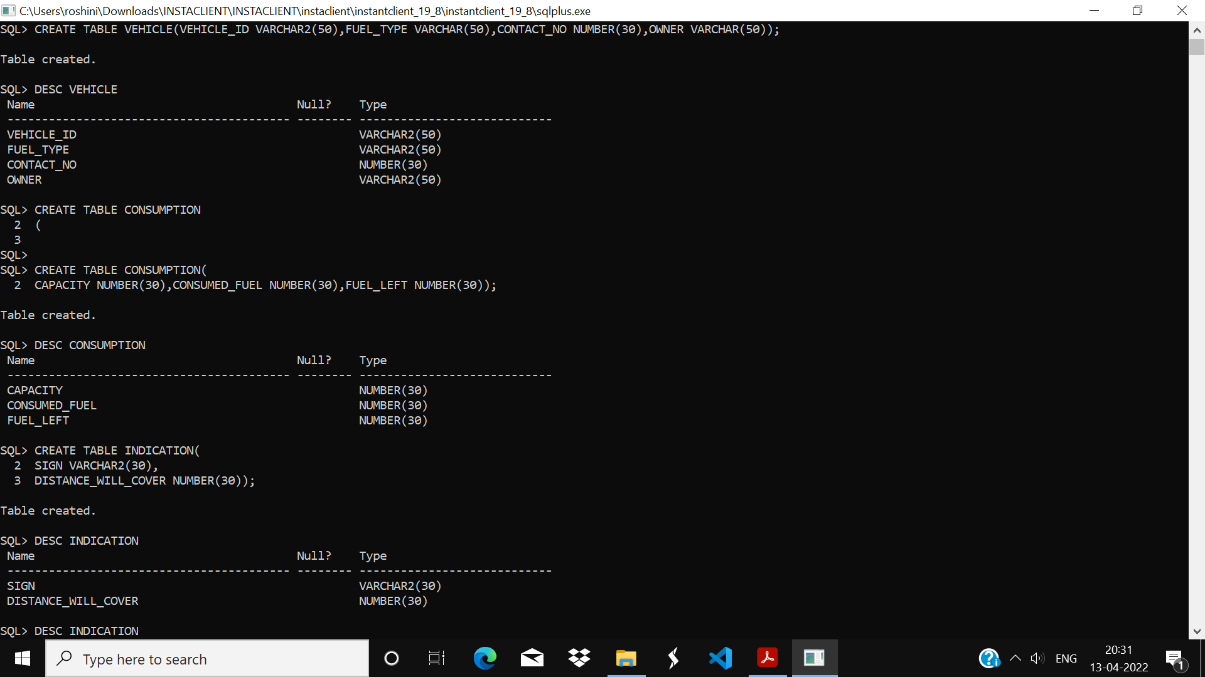

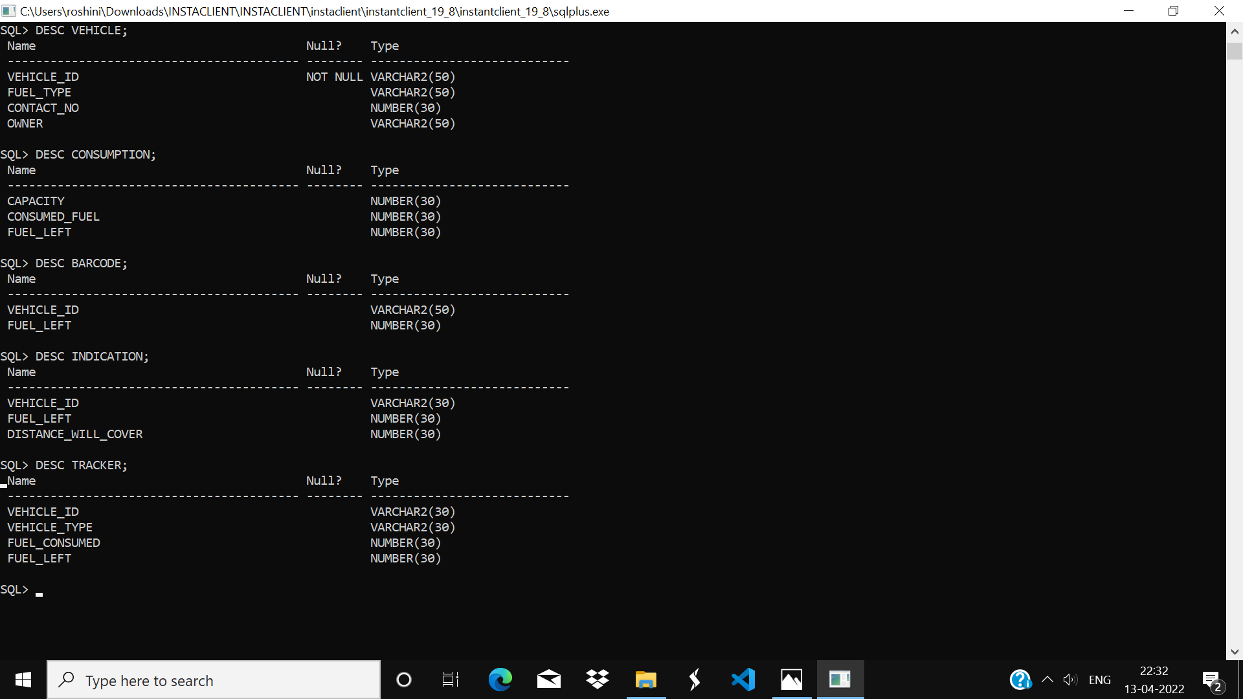

4.KEY CONSTRAINTS: ENFORCED PRIMARY CONSTRAINT ON ATTRIBUTE VEHICLE_ID OF VEHICLE TABLE AND FOREIGN CONSTRAINT ON CHILD TABLES BARCODE, TRACKER ON ATTRIBUTE VEHICLE_ID.

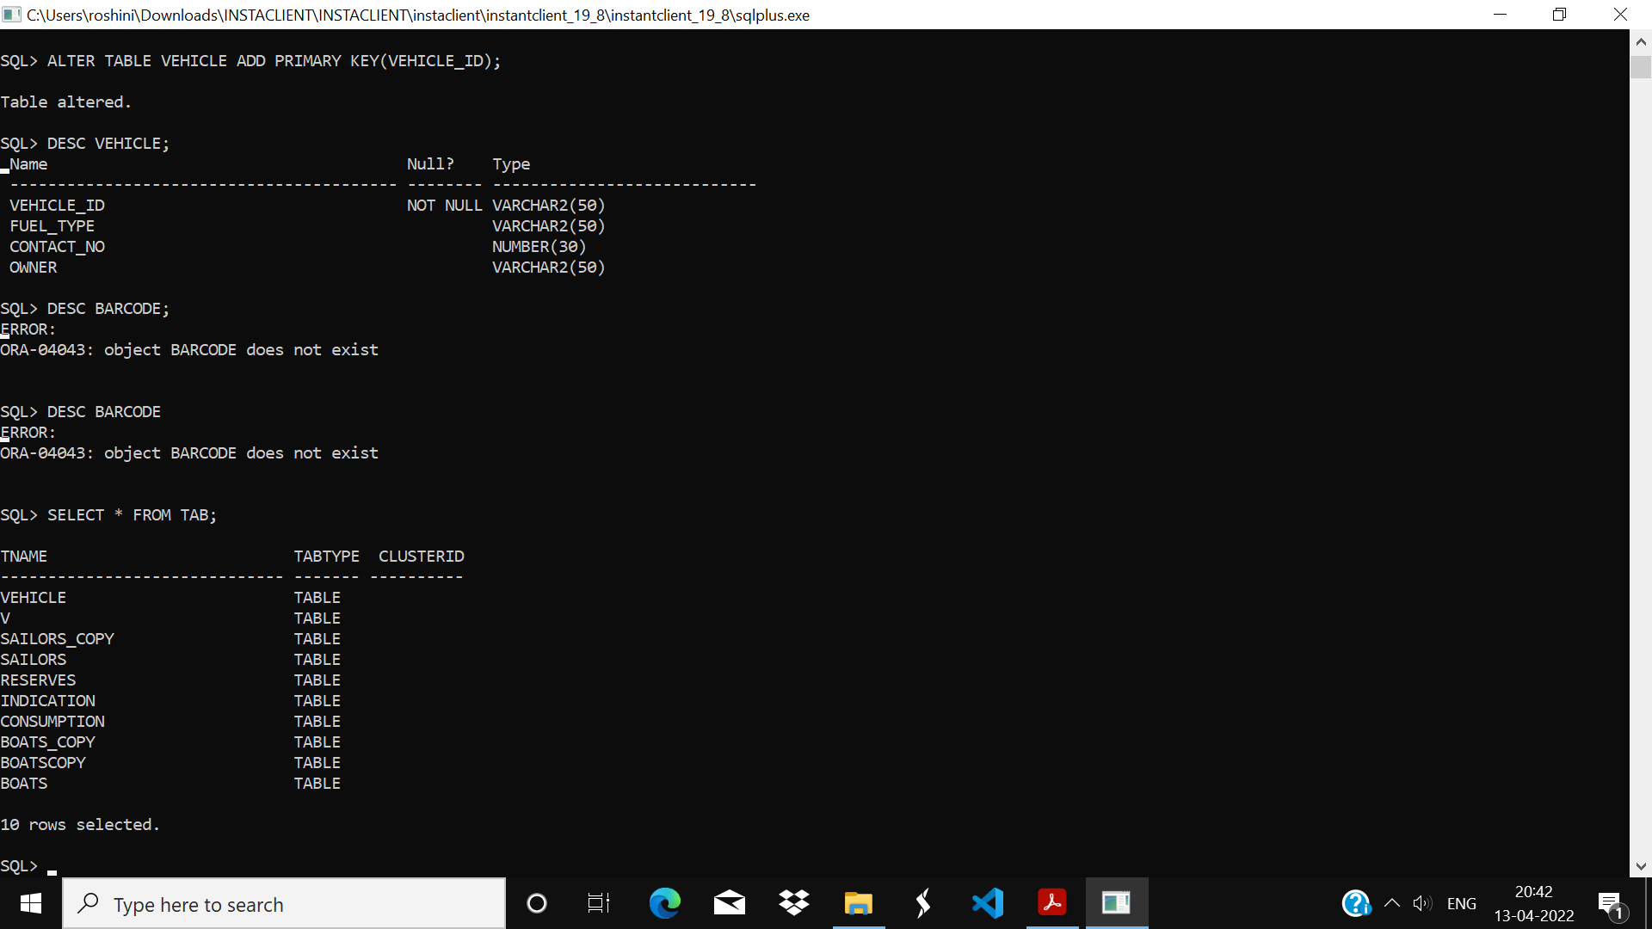

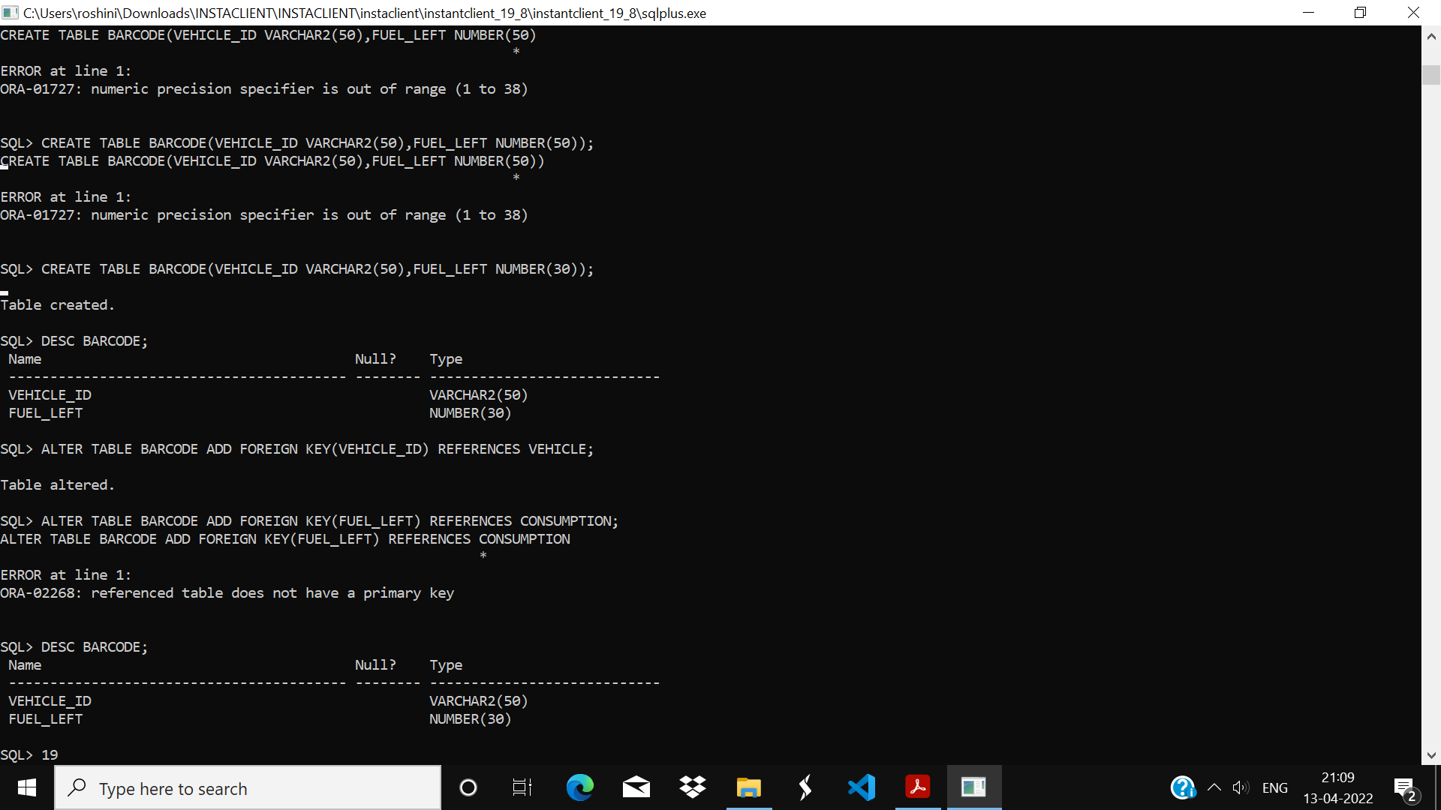

MODIFICATION OF DB: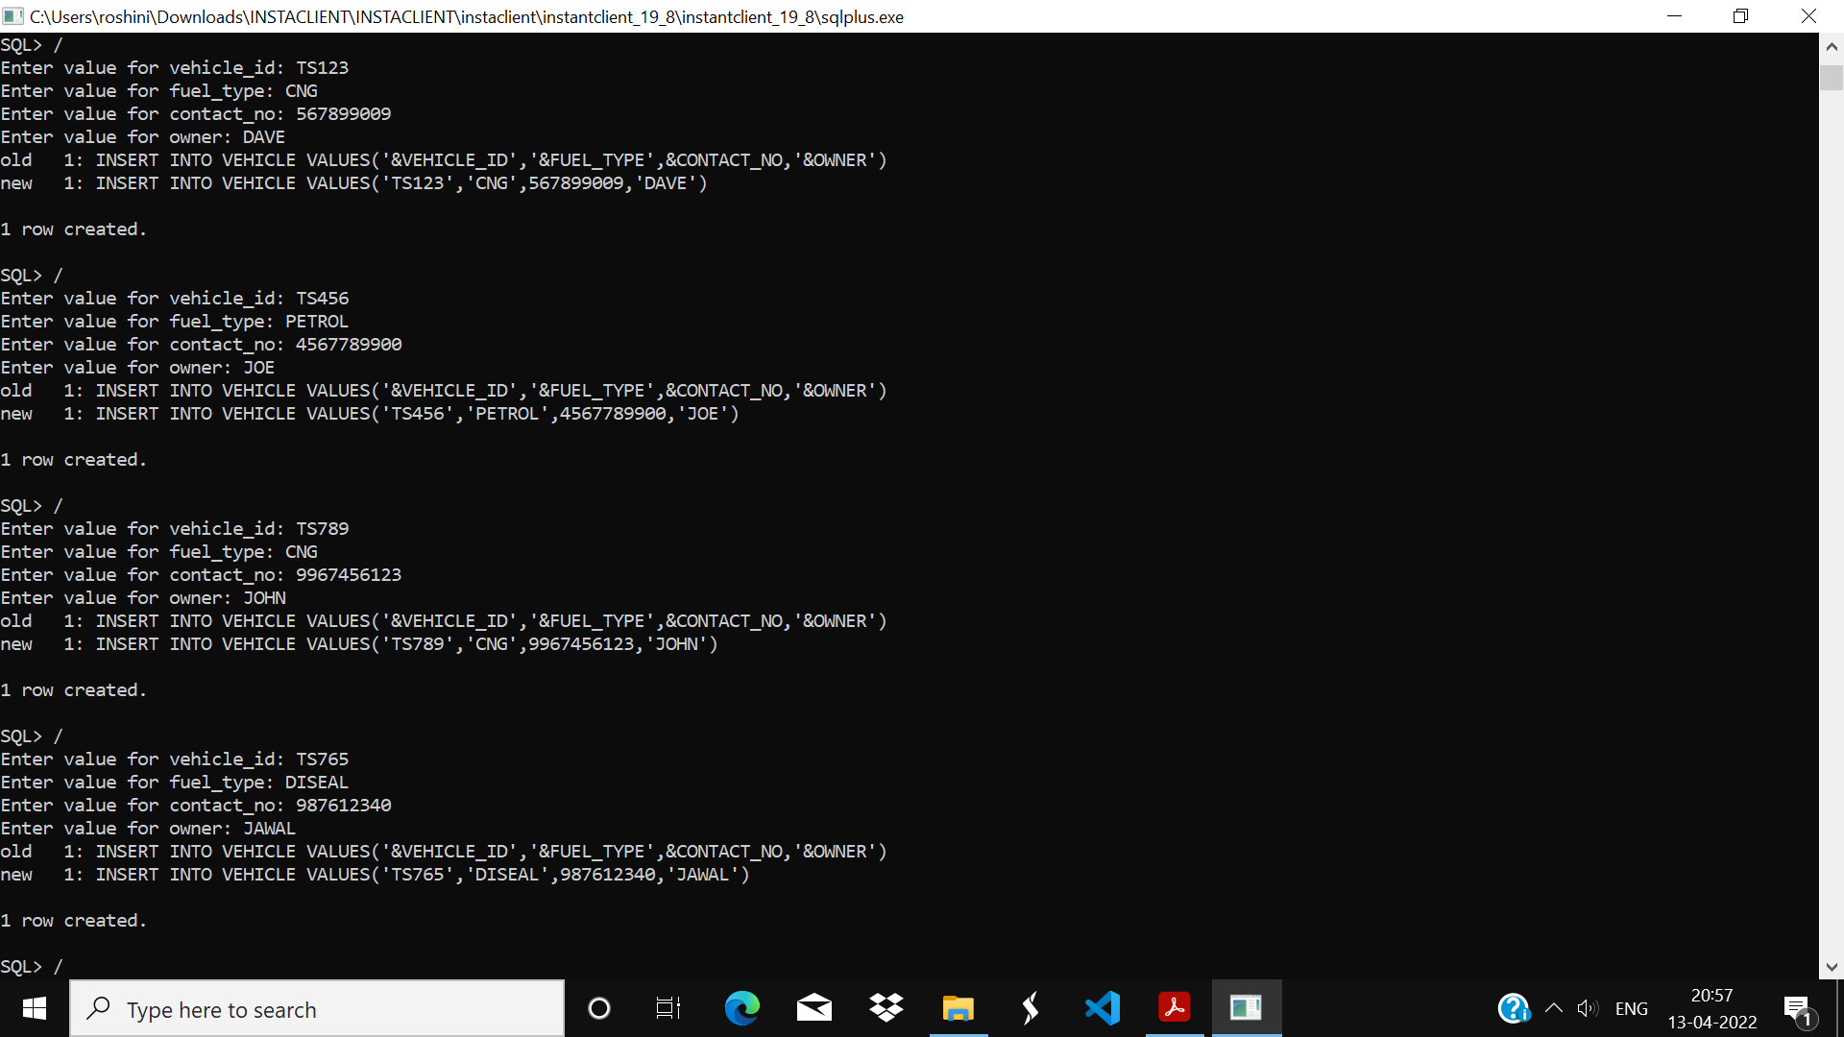

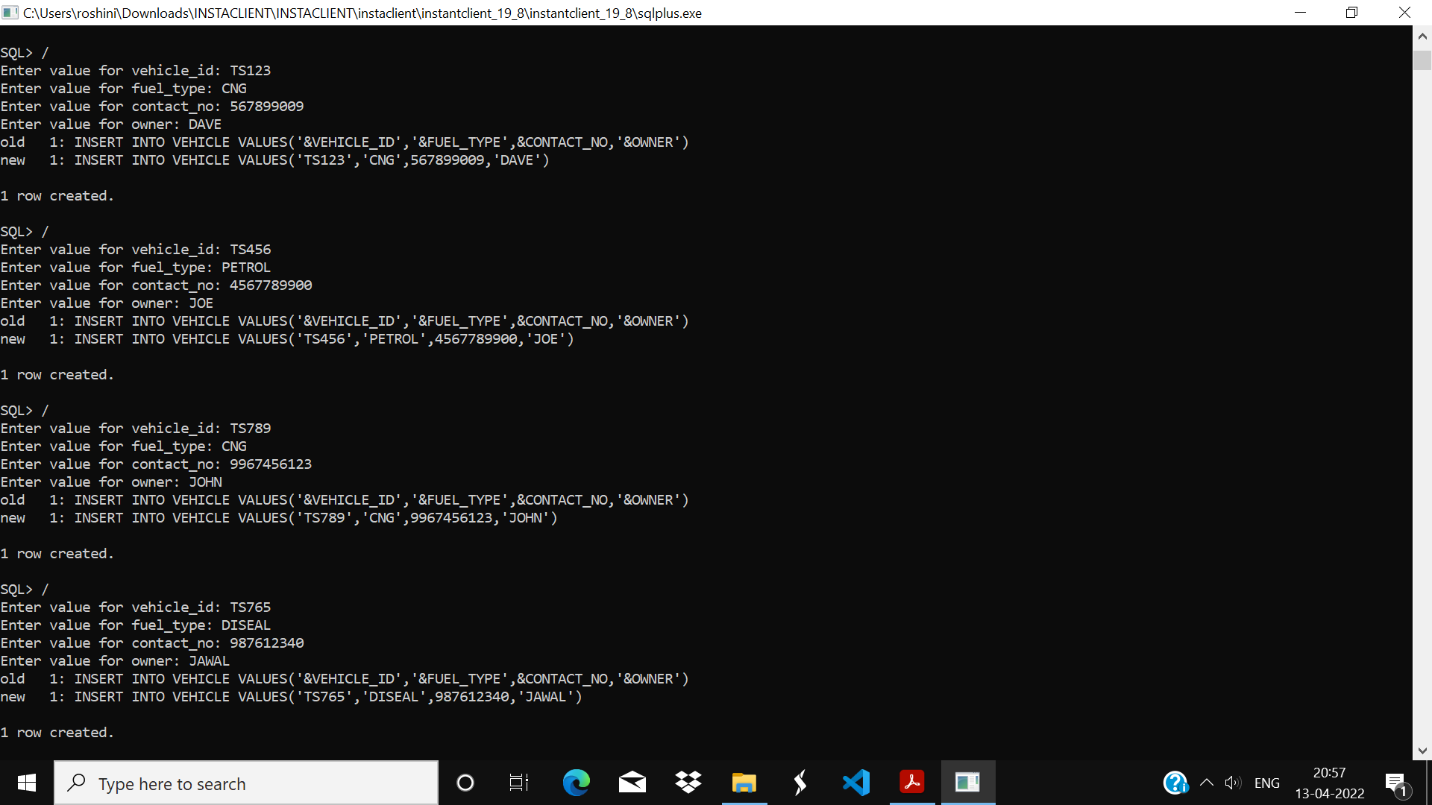

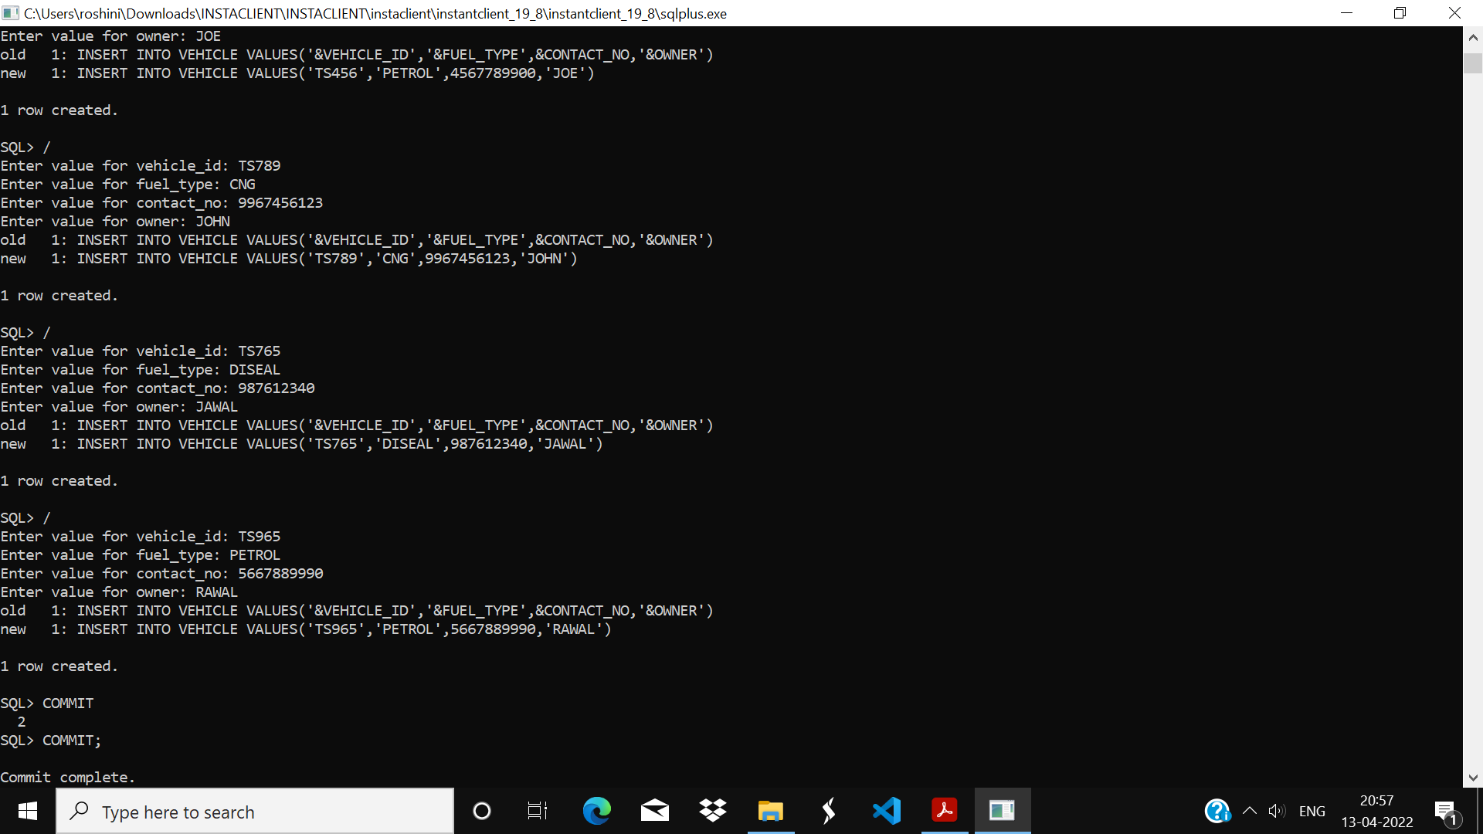

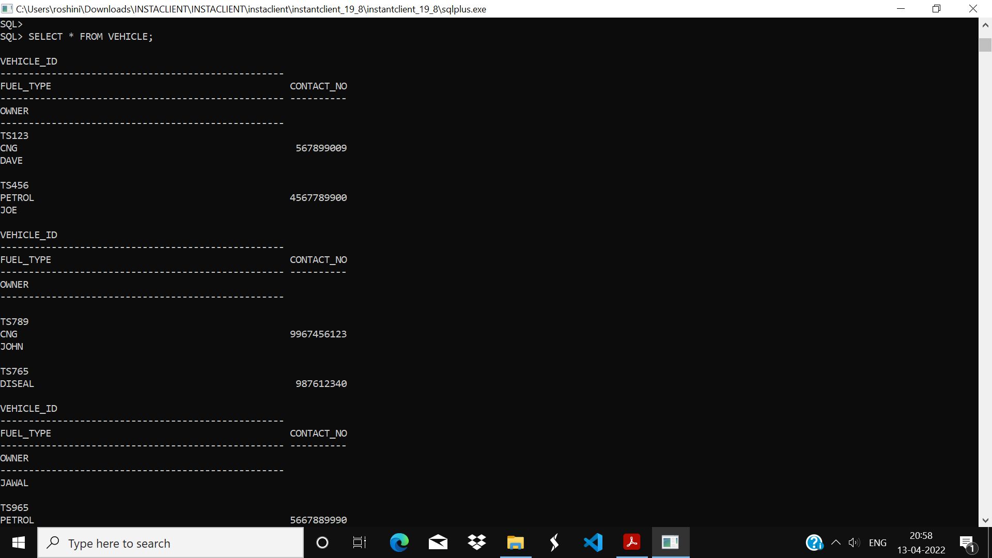

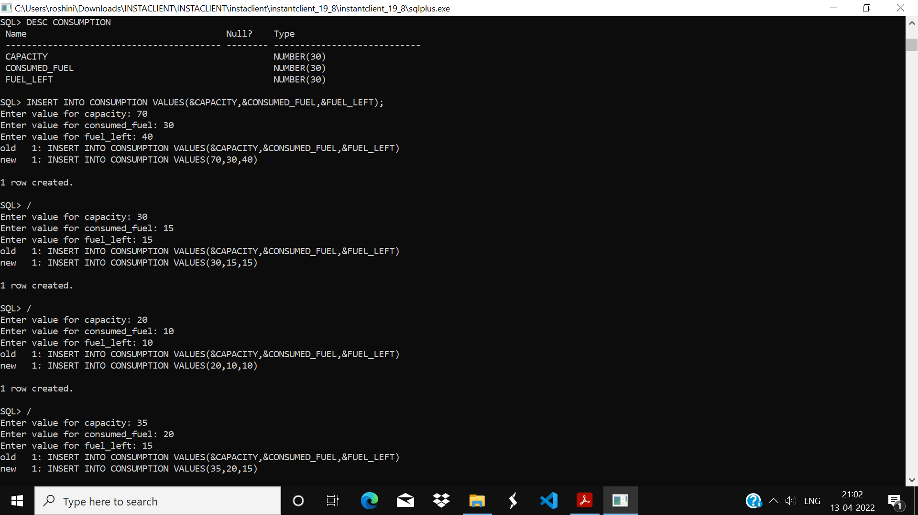

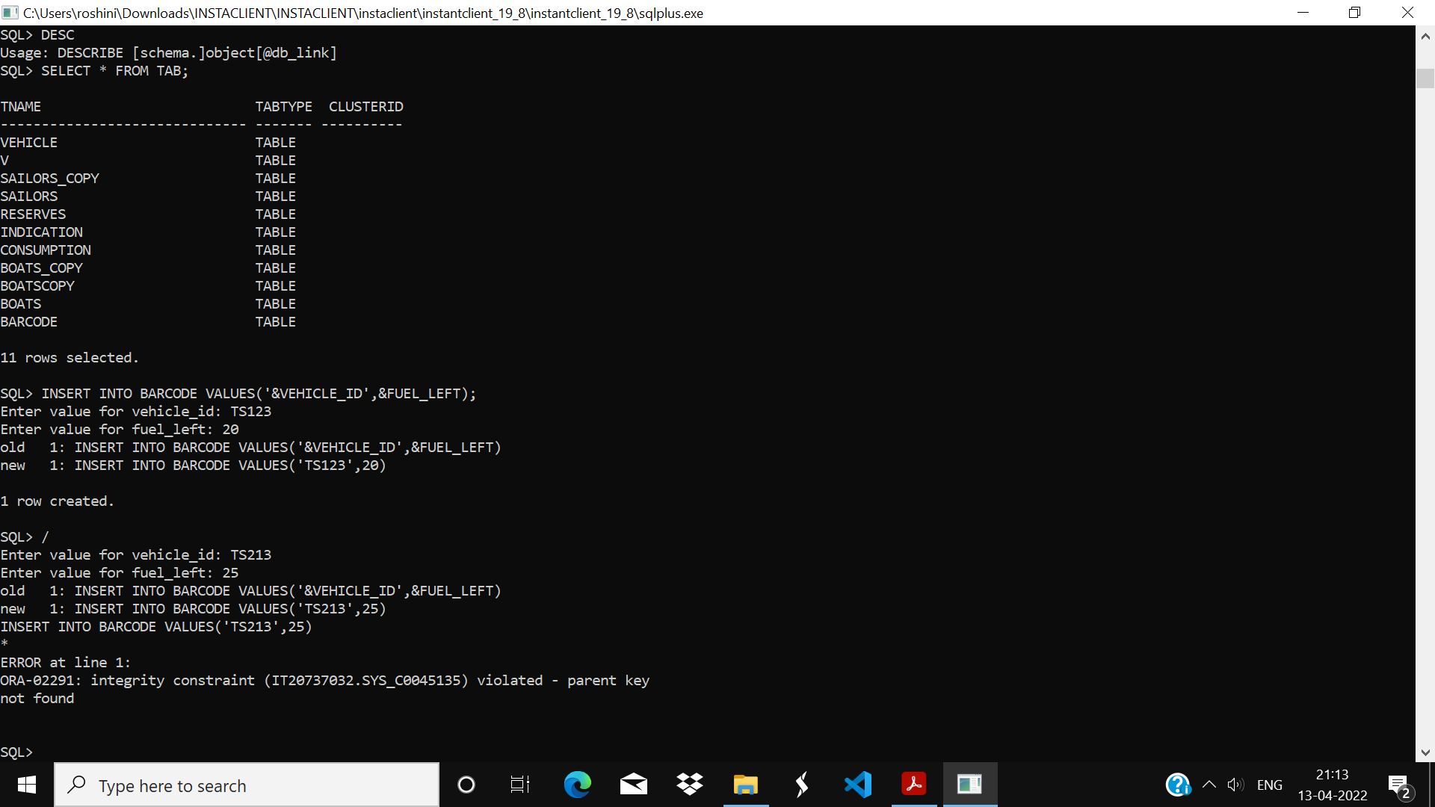

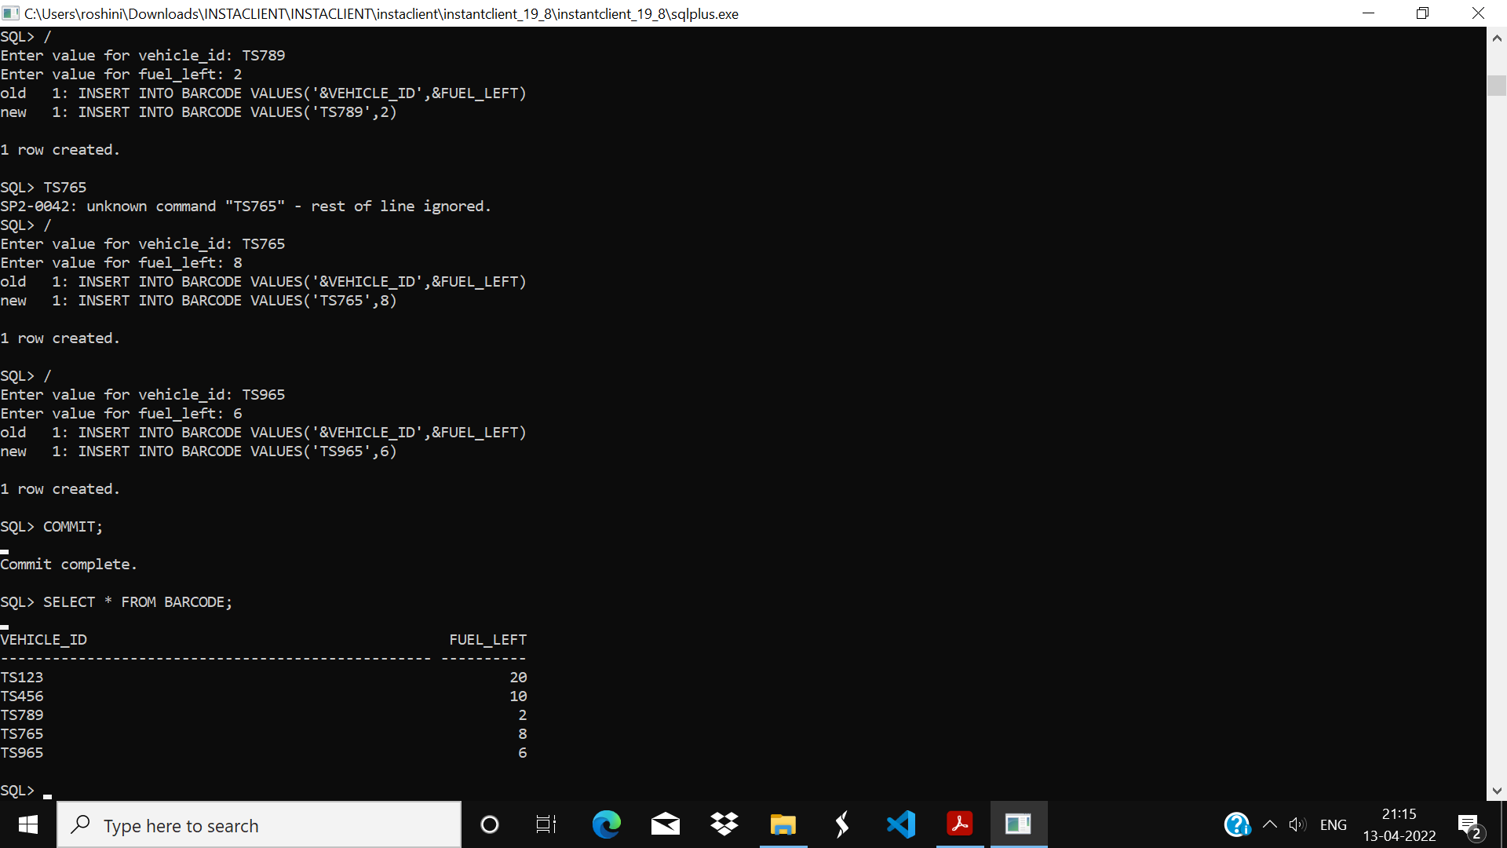

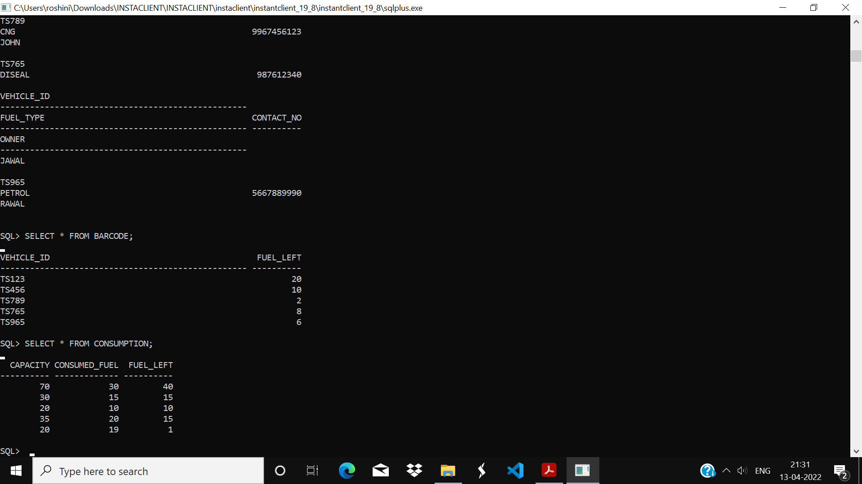

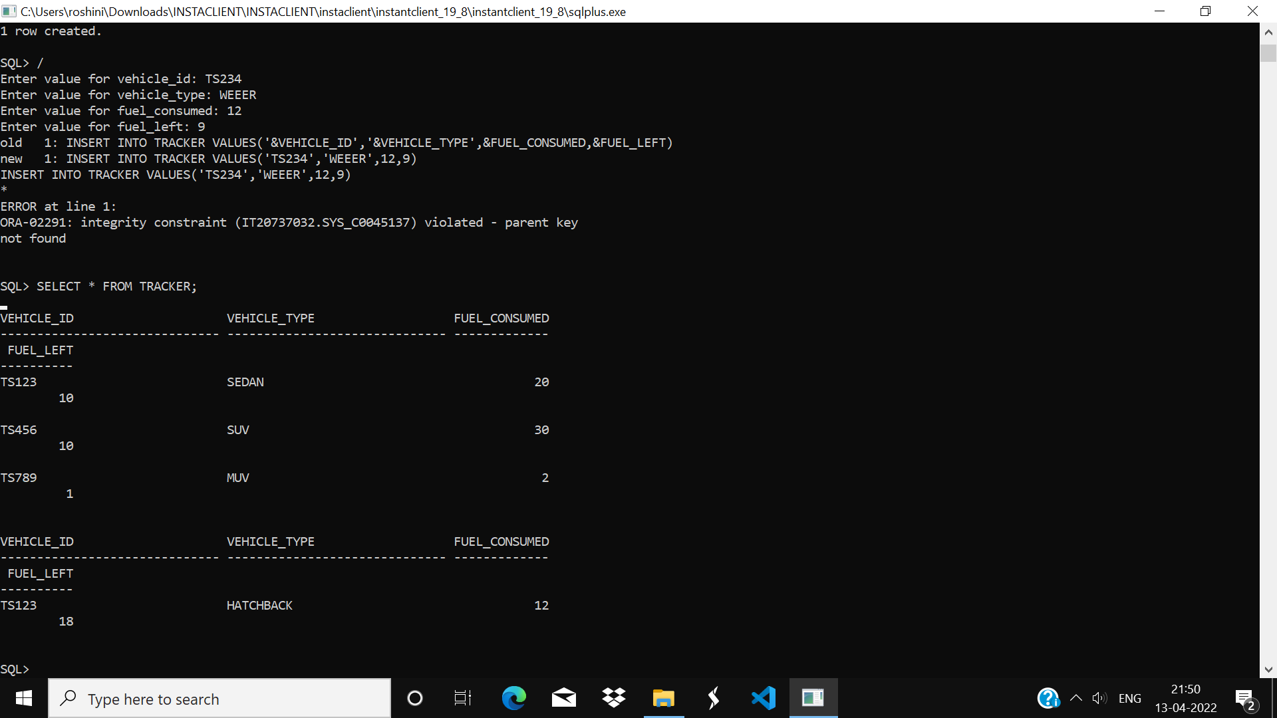

Connection details:

import java.sql.*;

public class conn {

public Connection conn;

public Statement s;

public PreparedStatement pstmt;

public conn(){

try{

Class.forName("oracle.jdbc.OracleDriver");

Connection conn=DriverManager.getConnection("jdbc:oracle:thin:@218.248.0.7:1521:rdbms","it20737032","vasavi");

System.out.println("Connected");

s = conn.createStatement();

}

catch(Exception e) {

e.printStackTrace();

}

}

Password

import java.awt.event.*;

import java.awt.*;

import java.awt.event.ActionListener;

import javax.swing.*;

import java.sql.*;

public class password extends JFrame implements ActionListener{

JLabel l1,l2,l3;

JButton b1,b2;

JTextField t1;

JPasswordField t2,t3;

password()

{

super("Password");

setLayout(new BorderLayout());

t1 = new JTextField(20);

t2 = new JPasswordField(20);

t3 = new JPasswordField(20);

b1 = new JButton("Submit");

b2 = new JButton("Cancel");

b1.addActionListener(this);

b2.addActionListener(this);

JPanel p1,p2;

p1 = new JPanel();

p2 = new JPanel();

p1.add(new JLabel("Enter Your Email "));

p1.add(t1);

p1.add(new JLabel("Enter New Password "));

p1.add(t2);

p1.add(new JLabel("Re-Enter Password "));

p1.add(t3);

p2.add(b1);

p2.add(b2);

add(p1,BorderLayout.CENTER);

add(p2,BorderLayout.SOUTH);

setSize(400,250);

setLocation(600,400);

setVisible(true);

}

@Override

public void actionPerformed(ActionEvent ae) {

JButton b=(JButton)ae.getSource();

try{

conn c1=new conn();

String m=t1.getText();

String query="Select email from login";

ResultSet rs=c1.s.executeQuery(query);

if(rs.next()){

System.out.println("Email matches");

String u=t2.getText();

String v=t3.getText();

if(u.equals(v))

{

System.out.println("Password matches");

String q="Update login set password='"+u+"' where username='admin'";

c1.s.executeUpdate(q);

System.out.println("Updated");

JOptionPane.showMessageDialog(null,"Password Updated");

new login().setVisible(true);

setVisible(false);

}

else

{

JOptionPane.showMessageDialog(null,"Password Does Not Match");

}

}

else{

JOptionPane.showMessageDialog(null,"Invaid Mail");

setVisible(false);

}

}

catch(Exception e){

}

}

public static void main(String args[])

{

new password();

}

}

New vehicle registration

import javax.swing.*;

import java.awt.*;

import java.awt.event.*;

public class New_Vehicle extends JFrame implements ActionListener{

JLabel l1,l2,l3,l4,l5,l6,l7;

JTextField t1,t2,t3,t4,t5,t6,t7;

JButton b1,b2;

Choice c1;

New_Vehicle(){

super("New Vehicle");

setSize(600,650);

setLocation(600,200);

getContentPane().setBackground(Color.BLACK);

JPanel p1= new JPanel();

p1.setBackground(Color.BLACK);

p1.setLayout(new GridLayout(8,2,10,40));

l1 = new JLabel("Name");

l1.setForeground(Color.WHITE);

t1 = new JTextField(15);

t1.setBackground(Color.BLACK);

t1.setForeground(Color.WHITE);

p1.add(l1);

p1.add(t1);

c1 = new Choice();

c1.add("Male");

c1.add("Female");

c1.add("Others");

c1.setBackground(Color.BLACK);

c1.setForeground(Color.WHITE);

l2 = new JLabel("Gender");

l2.setForeground(Color.WHITE);

p1.add(l2);

p1.add(c1);

l3 = new JLabel("Address");

l3.setForeground(Color.WHITE);

t3 = new JTextField(15);

t3.setBackground(Color.BLACK);

t3.setForeground(Color.WHITE);

p1.add(l3);

p1.add(t3);

l4 = new JLabel("State");

l4.setForeground(Color.WHITE);

t4 = new JTextField(15);

t4.setBackground(Color.BLACK);

t4.setForeground(Color.WHITE);

p1.add(l4);

p1.add(t4);

l5 = new JLabel("City");

l5.setForeground(Color.WHITE);

t5 = new JTextField(15);

t5.setBackground(Color.BLACK);

t5.setForeground(Color.WHITE);

p1.add(l5);

p1.add(t5);

l6 = new JLabel("Email");

l6.setForeground(Color.WHITE);

t6 = new JTextField(15);

t6.setBackground(Color.BLACK);

t6.setForeground(Color.WHITE);

p1.add(l6);

p1.add(t6);

l7 = new JLabel("phone");

l7.setForeground(Color.WHITE);

t7= new JTextField(15);

t7.setBackground(Color.BLACK);

t7.setForeground(Color.WHITE);

p1.add(l7);

p1.add(t7);

b1 =new JButton("Submit");

b2 = new JButton("Cancel");

p1.add(b1);

p1.add(b2);

setLayout(new BorderLayout());

add(new JLabel(new ImageIcon

(ClassLoader.getSystemResource("icons/new_vehicle.png"))),"West");

add(p1,"Center");

b1.addActionListener(this);

b1.setBackground(Color.BLACK);

b1.setForeground(Color.WHITE);

b2.addActionListener(this);

b2.setBackground(Color.BLACK);

b2.setForeground(Color.WHITE);

}

@Override

public void actionPerformed(ActionEvent ae){

String n = t1.getText();

String g = c1.getSelectedItem();

String a = t3.getText();

String s = t4.getText();

String c = t5.getText();

String e = t6.getText();

String p = t7.getText();

String qry = "insert into vehicle values(null,'"+n+"','"+g+"','"+a+"','"+s+"','"+c+"','"+e+"','"+p+"')";

try{

conn c1 = new conn();

c1.s.executeUpdate(qry);

JOptionPane.showMessageDialog(null,"vehicle registered");

this.setVisible(false);

}

catch(Exception ee){

ee.printStackTrace();

}

}

public static void main(String s[]){

new New_Vehicle().setVisible(true);

}

}

Update vehicle registration

import java.sql.*;

import javax.swing.*;

import java.awt.*;

import java.awt.event.*;

public class Update_vehicle extends JFrame implements ActionListener,ItemListener{

JLabel l1,l2,l3,l4,l5,l6,l7,emp;

JTextField t1,t2,t3,t4,t5,t6,t7;

JButton b1,b2;

Choice c1,c2;

Update_vehicle(){

super("Update Vehicle details");

setLayout(null);

getContentPane().setBackground(Color.WHITE);

c2 = new Choice();

c2.setForeground(Color.WHITE);

c2.setBackground(Color.BLACK);

c2.setBounds(160,40,200,20);

try{

conn c = new conn();

ResultSet rs = c.s.executeQuery("select * from vehicle");

while(rs.next()){

c2.add(rs.getString("vehicle_id"));

}

}catch(Exception e){ }

vehicle_no = new JLabel("Select vehicle_no");

vehicle_no.setForeground(Color.WHITE);

vehicle_no.setBackground(Color.BLACK);

vehicle_no.setBounds(40,40,100,20);

add(vehicle_no);

add(c2);

l1 = new JLabel("Name : ");

l1.setForeground(Color.WHITE);

l1.setBackground(Color.BLACK);

t1 = new JTextField(15);

t1.setForeground(Color.WHITE);

t1.setBackground(Color.BLACK);

l1.setBounds(40,80,100,20);

t1.setBounds(160,80,200,20);

add(l1);

add(t1);

c1 = new Choice();

c1.setForeground(Color.WHITE);

c1.setBackground(Color.BLACK);

c1.add("Male");

c1.add("Female");

l2 = new JLabel("Gender : ");

l2.setForeground(Color.WHITE);

l2.setBackground(Color.BLACK);

l2.setBounds(40,120,100,20);

c1.setBounds(160,120,200,20);

add(l2);

add(c1);

l3 = new JLabel("Address : ");

l3.setForeground(Color.WHITE);

l3.setBackground(Color.BLACK);

t3 = new JTextField(15);

t3.setForeground(Color.WHITE);

t3.setBackground(Color.BLACK);

l3.setBounds(40,160,100,20);

t3.setBounds(160,160,200,20);

add(l3);

add(t3);

l4 = new JLabel("State : ");

l4.setForeground(Color.WHITE);

l4.setBackground(Color.BLACK);

t4 = new JTextField(15);

t4.setForeground(Color.WHITE);

t4.setBackground(Color.BLACK);

l4.setBounds(40,200,100,20);

t4.setBounds(160,200,200,20);

add(l4);

add(t4);

l5 = new JLabel("City : ");

l5.setForeground(Color.WHITE);

l5.setBackground(Color.BLACK);

t5 = new JTextField(15);

t5.setForeground(Color.WHITE);

t5.setBackground(Color.BLACK);

l5.setBounds(40,240,100,20);

t5.setBounds(160,240,200,20);

add(l5);

add(t5);

l6 = new JLabel("Email : ");

l6.setForeground(Color.WHITE);

l6.setBackground(Color.BLACK);

t6 = new JTextField(15);

t6.setForeground(Color.WHITE);

t6.setBackground(Color.BLACK);

l6.setBounds(40,280,100,20);

t6.setBounds(160,280,200,20);

add(l6);

add(t6);

l7 = new JLabel("phone : ");

l7.setForeground(Color.WHITE);

l7.setBackground(Color.BLACK);

t7= new JTextField(15);

t7.setForeground(Color.WHITE);

t7.setBackground(Color.BLACK);

l7.setBounds(40,320,100,20);

t7.setBounds(160,320,200,20);

add(l7);

add(t7);

b1 =new JButton("Update");

b2 = new JButton("Delete");

b1.setBounds(40,400,150,30);

b2.setBounds(200,400,150,30);

add(b1);

add(b2);

b1.setBackground(Color.BLACK);

b1.setForeground(Color.WHITE);

b2.setBackground(Color.BLACK);

b2.setForeground(Color.WHITE);

b1.addActionListener(this);

b2.addActionListener(this);

c2.addItemListener(this);

setVisible(true);

setSize(400,550);

setLocation(600,200);

getContentPane().setBackground(Color.BLACK);

}

public void actionPerformed(ActionEvent ae){

if(ae.getSource()==b1){String n = t1.getText();

String g = c1.getSelectedItem();

String a = t3.getText();

String s = t4.getText();

String c = t5.getText();String e = t6.getText();

String p = t7.getText();

String qry = "update vehicle set name='"+n+"',gender='"+g+"',address='"+a+"',state='"+s+"',city='"+c+"',email='"+e+"',phone='"+p+"' where vehicle_id="+c2.getSelectedItem();

try{

conn c1 = new conn();

c1.s.executeUpdate(qry);

JOptionPane.showMessageDialog(null,"Vehicle details Updated");

}

catch(Exception ee){

ee.printStackTrace();

}

}

if(ae.getSource()==b2){

try{

conn c1 = new conn();

c1.s.executeUpdate("delete from vehicle where vehicle_id="+c2.getSelectedItem());

JOptionPane.showMessageDialog(null,"vehicle details Deleted");

this.setVisible(false);

}catch(Exception ee){

ee.printStackTrace();

}

}

}

public void itemStateChanged(ItemEvent ie){

try{

conn c1 = new conn();

ResultSet rs = c1.s.executeQuery("select * from vehicle where vehicle_id="+c2.getSelectedItem());

if(rs.next()){

t1.setText(rs.getString("name"));

t3.setText(rs.getString("address"));

t4.setText(rs.getString("state"));

t5.setText(rs.getString("city"));

t6.setText(rs.getString("email"));

t7.setText(rs.getString("phone"));

}

}

catch(Exception ee){

ee.printStackTrace();

}

}

public static void main(String[] args){

Update_vehicle update_vehicle = new Update_vehicle();

}

}

Consumption

import java.sql.*;

import javax.swing.*;

import java.awt.*;

import java.awt.event.*;

public class Consumption extends JFrame implements ActionListener{

JLabel l1,l2,l3,l4,l5,l6,l7,l8;

JTextField t1,t3,t4,t5,t6,t7;

JButton b1,b2;

Choice c2;

Consumption(){

super("Consumption details");

setLayout(new GridLayout(8,2,20,20));

c2 = new Choice();

c2.setBackground(Color.BLACK);

c2.setForeground(Color.WHITE);

try{

conn c = new conn();

ResultSet rs = c.s.executeQuery("select * from vehicle");

while(rs.next()){

c2.add(rs.getString("vehicle_id"));

}

}catch(Exception e){ }

l8=new JLabel("select vehicle_no ");

l8.setForeground(Color.WHITE);

add(l8);

add(c2);

l1 = new JLabel("min_fuel");

l1.setBackground(Color.BLACK);

l1.setForeground(Color.WHITE);

t1 = new JTextField(10);

t1.setBackground(Color.BLACK);

t1.setForeground(Color.WHITE);

add(l1);

add(t1);

l3 = new JLabel("min_distance");

l3.setBackground(Color.BLACK);

l3.setForeground(Color.WHITE);

t3 = new JTextField(5);

t3.setBackground(Color.BLACK);

t3.setForeground(Color.WHITE);

add(l3);

add(t3);

l4 = new JLabel("fuel_left");

l4.setBackground(Color.BLACK);

l4.setForeground(Color.WHITE);

t4 = new JTextField(15);

t4.setBackground(Color.BLACK);

t4.setForeground(Color.WHITE);

add(l4);

add(t4);

l5 = new JLabel("fuel_consumed");

l5.setBackground(Color.BLACK);

l5.setForeground(Color.WHITE);

t5 = new JTextField(10);

t5.setBackground(Color.BLACK);

t5.setForeground(Color.WHITE);

add(l5);

add(t5);

l6 = new JLabel("distance_covered");

l6.setBackground(Color.BLACK);

l6.setForeground(Color.WHITE);

t6 = new JTextField(15);

t6.setBackground(Color.BLACK);

t6.setForeground(Color.WHITE);

add(l6);

add(t6);

b1 =new JButton("Submit");

b1.setBackground(Color.BLACK);

b1.setForeground(Color.WHITE);

b2 = new JButton("Cancel");

b2.setBackground(Color.BLACK);

b2.setForeground(Color.WHITE);

add(b1);

add(b2);

b1.addActionListener(this);

b2.addActionListener(this);

setSize(450,550);

setLocation(500,200);

setVisible(true);

getContentPane().setBackground(Color.BLACK);

}

@Override

public void actionPerformed(ActionEvent ae){

Double min_fuel = Double.parseDouble(t1.getText());

Double vehicle_id = Double.parseDouble(c2.getSelectedItem());

Double min_distance = Double.parseDouble(t3.getText());

Double fuel_left= Double.parseDouble(t4.getText());

Double fuel_consumed = Double.parseDouble(t5.getText());

Double distance_covered = Double.parseDouble(t6.getText());

String qry = "insert into consumption values('"+ min_fuel+"','"+ min_distance +"','"+fuel_left+"','"+fuel_consumed+"','"+distance_covered+"')";

try{

conn c1 = new conn();

c1.s.executeUpdate(qry);

JOptionPane.showMessageDialog(null,"consumption details saved");

this.setVisible(false);

}catch(Exception ee){

ee.printStackTrace();

}

}

public static void main(String[] args){

new Consumption().setVisible(true);

}

}

Update consumption details

import java.sql.*;

import javax.swing.*;

import java.awt.*;

import java.awt.event.*;

public class Update_consumption extends JFrame implements ActionListener,ItemListener{

JLabel l1,l2,l3,l4,l5,l6;

JTextField t1,t2,t3,t4,t5,t6;

JButton b1,b2;

Choice c2;

Update_consumption(){

setLayout(null);

c2 = new Choice();

try{

conn c = new conn();

ResultSet rs = c.s.executeQuery("select * from consumption");

while(rs.next()){

c2.add(rs.getString("vehicle_id"));

}

}catch(SQLException e){ }

JLabel vehicle_no = new JLabel("Select vehicle_no");

vehicle_no.setBackground(Color.BLACK);

vehicle_no.setForeground(Color.WHITE);

vehicle_no.setBounds(20,20,100,20);

add(vehicle_no);

c2.setBounds(120,20,200,20);

c2.setBackground(Color.BLACK);

c2.setForeground(Color.WHITE);

add(c2);

l1 = new JLabel("min_fuel");

l1.setBackground(Color.BLACK);

l1.setForeground(Color.WHITE);

t1 = new JTextField(15);

t1.setBackground(Color.BLACK);

t1.setForeground(Color.WHITE);

l1.setBounds(20,60,100,20);

t1.setBounds(120,60,200,20);

add(l1);

add(t1);

l2 = new JLabel("min_distance");

l2.setBackground(Color.BLACK);

l2.setForeground(Color.WHITE);

t2 = new JTextField(15);

t2.setBackground(Color.BLACK);

t2.setForeground(Color.WHITE);

l2.setBounds(20,100,100,20);

t2.setBounds(120,100,200,20);

add(l2);

add(t2);

l3 = new JLabel("fuel_left");

l3.setBackground(Color.BLACK);

l3.setForeground(Color.WHITE);

t3 = new JTextField(15);

t3.setBackground(Color.BLACK);

t3.setForeground(Color.WHITE);

l3.setBounds(20,140,100,20);

t3.setBounds(120,140,200,20);

add(l3);

add(t3);

l4 = new JLabel("fuel_consumed");

l4.setBackground(Color.BLACK);

l4.setForeground(Color.WHITE);

t4 = new JTextField(15);

t4.setBackground(Color.BLACK);

t4.setForeground(Color.WHITE);

l4.setBounds(20,180,100,20);

t4.setBounds(120,180,200,20);

add(l4);

add(t4);

l5 = new JLabel("distance_covered");

l5.setBackground(Color.BLACK);

l5.setForeground(Color.WHITE);

t5 = new JTextField(15);

t5.setBackground(Color.BLACK);

t5.setForeground(Color.WHITE);

l5.setBounds(20,220,100,20);

t5.setBounds(120,220,200,20);

add(l5);

add(t5);

b1 =new JButton("Update");

b1.setBackground(Color.BLACK);

b1.setForeground(Color.WHITE);

b2 = new JButton("Delete");

b2.setBackground(Color.BLACK);

b2.setForeground(Color.WHITE);

b1.setBounds(40,280,100,20);

b2.setBounds(200,280,100,20);

add(b1);

add(b2);

b1.addActionListener(this);

b2.addActionListener(this);

c2.addItemListener(this);

getContentPane().setBackground(Color.BLACK) ;

setVisible(true);

setSize(400,450);

setLocation(600,200);

}

@Override

public void actionPerformed(ActionEvent ae){

if(ae.getSource()==b1){

Double min_fuel = Double.parseDouble(t1.getText());

Double vehicle_id = Double.parseDouble(c2.getSelectedItem());

Double min_distance = Double.parseDouble(t2.getText());

Double fuel_left = Double.parseDouble(t3.getText());

Double fuel_consumed = Double.parseDouble(t4.getText());

Double distance_covered= Double.parseDouble(t5.getText());

String qry = "update consumption set fuel_left="+fuel_left+",fuel_consumed="+fuel_consumed+",distance_covered="+distance_covered+",min_distance="+min_distance+" where vehicle_id="+c2.getSelectedItem();

try{

conn c1 = new conn();

c1.s.executeUpdate(qry);

JOptionPane.showMessageDialog(null,"consumption details Updated");

this.setVisible(false);

}catch(Exception ee){

ee.printStackTrace();

}

}

if(ae.getSource()==b2){

try{

conn c1 = new conn();

c1.s.executeUpdate("delete from consumption where vehicle_id="+c2.getSelectedItem());

JOptionPane.showMessageDialog(null,"consumption details Deleted");

this.setVisible(false);

}catch(Exception ee){

ee.printStackTrace();

}

}

}

@Override

public void itemStateChanged(ItemEvent ie)

{

try{

conn c1 = new conn();

ResultSet rs = c1.s.executeQuery("select * from consumption where vehicle_id="+c2.getSelectedItem());

if(rs.next()){

t1.setText(rs.getString("min_fuel"));

t2.setText(rs.getString("min_distance"));

t3.setText(rs.getString("fuel_left"));

t4.setText(rs.getString("fuel_consumed"));

t5.setText(rs.getString("distance_covered"));

}

}catch(Exception ee){

ee.printStackTrace();

}

}

public static void main(String[] args){

new Update_consumption();

}

}

List vehicle

import java.sql.*;

import javax.swing.*;

import java.awt.*;

import java.awt.event.*;

public class List_Vehicle extends JFrame implements ActionListener{

JTable j1;

JButton b1;

String h[]={"vehicle_id","Name","Gender","Address","State","City","Email id","phone"};

String d[][]=new String[20][8];

int i=0,j=0;

List_Vehicle(){

super("View vehicle details");

setSize(1000,400);

setLocation(450,200);

try{

String q="select * from vehicle";

conn c1=new conn();

ResultSet rs=c1.s.executeQuery(q);

while(rs.next()){

// i = 0 j = 0

d[i][j++]=rs.getString("vehicle_id");

d[i][j++]=rs.getString("name");

d[i][j++]=rs.getString("gender");

d[i][j++]=rs.getString("address");

d[i][j++]=rs.getString("state");

d[i][j++]=rs.getString("city");

d[i][j++]=rs.getString("email");

d[i][j++]=rs.getString("phone");

i++;

j=0;

}

j1=new JTable(d,h);

}

catch(Exception e){}

b1=new JButton("Print");

add(b1,"South");

JScrollPane s1=new JScrollPane(j1);

add(s1);

b1.addActionListener(this);

}

public void actionPerformed(ActionEvent ae){

try{

j1.print();

}catch(Exception e){}

}

public static void main(String s[]){

new List_Vehicle().setVisible(true);

}

}

Tracker details

mport java.sql.*;

import javax.swing.*;

import java.awt.*;

import java.awt.event.*;

public class Tracker_details extends JFrame implements ActionListener{

JLabel l1,l2,l3,l4,l5,l6,l7,l8;

JTextField t1,t2,t3,t4,t5,t6,t7;

JButton b1,b2;

Choice c2,fh,sh;

Tracker_details(){

setLayout(new GridLayout(4,2,50,50));

c2 = new Choice();

try{

conn c = new conn();

ResultSet rs = c.s.executeQuery("select * from vehicle");

while(rs.next()){

c2.add(rs.getString("vehicle_id"));

}

}catch(Exception e){ }

l8=new JLabel("Select vehicle_no");

l8.setForeground(Color.WHITE);

add(l8);

c2.setBackground(Color.BLACK);

c2.setForeground(Color.WHITE);

add(c2);

l1 = new JLabel("First Half");

l1.setForeground(Color.WHITE);

fh = new Choice();

fh.add("FUEL Present");

fh.add("low fuel");

fh.add("no fuel");

fh.setBackground(Color.BLACK);

fh.setForeground(Color.WHITE);

add(l1);

add(fh);

l2 = new JLabel("Second Half");

l2.setForeground(Color.WHITE);

sh = new Choice();

sh.add("FUEL Present");

sh.add("low fuel");

sh.add("no fuel");

sh.setBackground(Color.BLACK);

sh.setForeground(Color.WHITE);

add(l2);

add(sh);

b1 =new JButton("Submit");

b1.setBackground(Color.BLACK);

b1.setForeground(Color.WHITE);

b2 = new JButton("Cancel");

b2.setBackground(Color.BLACK);

b2.setForeground(Color.WHITE);

add(b1);

add(b2);

b1.addActionListener(this);

b2.addActionListener(this);

getContentPane().setBackground(Color.BLACK);

setVisible(true);

setSize(400,450);

setLocation(600,200);

}

@Override

public void actionPerformed(ActionEvent ae){

String f = fh.getSelectedItem();

String s = sh.getSelectedItem();

String dt = new java.util.Date().toString();

String id=c2.getSelectedItem();

String qry = "insert into Tracker values("+ id +",'"+dt+"','"+f+"','"+s+"')";

try{

conn c1 = new conn();

c1.s.executeUpdate(qry);

JOptionPane.showMessageDialog(null,"fuel details confirmed");

this.setVisible(false);

}catch(Exception ee){

ee.printStackTrace();

}

}

public static void main(String s[]){

new Tracker_details();

}

}

